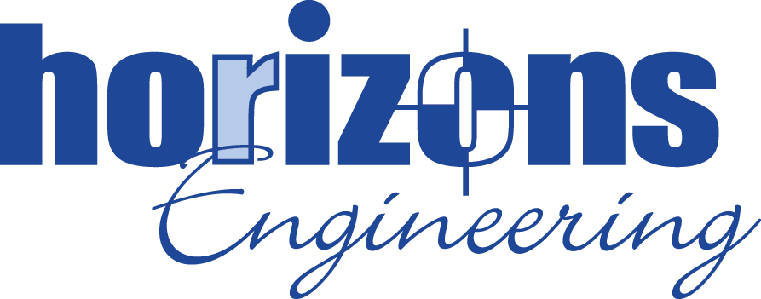
ENVIRONMENTAL SCIENTIST
Horizons Engineering Inc. is a reputable midsize Civil and Structural Engineering, Environmental services and Land Surveying firm, that proudly serves New Hampshire, Maine, and Vermont with expertise and dedication. With eight office locations strategically located across the region, we are deeply rooted in our communities and committed to delivering innovative solutions to our clients.

Horizons has an immediate opening for an Environmental Scientist in our Littleton, NH office. This position will be based in our Littleton office, with frequent collaboration with our other New Hampshire, Vermont, and Maine offices. We are looking for an enthusiastic and talented individual to become part of our team.

The position involves assisting environmental project managers and other team members with groundwater sampling, soil sampling, oversight of test pitting, ESA site walks, and report writing.

Our staff at Horizons is a close‐knit group of hard‐working individuals who value client service, design innovation, and a no‐nonsense approach. The successful candidate will have a strong work ethic, desire to learn, and interest in working on a wide range of environmental engineering projects throughout northern New England.

Essential Job Duties:
- Initial job duty will be to conduct field activities including soil boring advancement, groundwater monitoring well installation, groundwater sampling, vapor intrusion assessments, groundwater elevation surveys, etc.
- Field data evaluation /reduction
- Site inspections for Environmental Assessments (Phase I and II ESAs, Transaction Screen Assessments)
- Local and state records research
- Technical report writing

Required Skills and Abilities:
- Self-motivated with a strong desire to work hard, learn, and successfully face new challenges
- 1-3 (or more) years experience in the environmental field working on environmental assessment/remediation sites.
- 1 – 3 (or more) years of experience conducting ASTM Phase I & II Environmental Site Assessment activities
- Computer skills (Word, Excel, etc.) are a must
- Ability to complete field work including lifting up to 40 lbs., walking undeveloped sites, with occasional field days requiring several miles of hiking; and
- Ability to work on various tasks depending on skill sets (Groundwater sampling, soil sampling, well install, product recovery, remedial system O&M, various remedial actions, data evaluation, and report writing
- A valid driver’s license and reliable transportation are a must

Preferred Skills:
- Strong attention to detail
- Excellent written, oral, and interpersonal communication skills
- Ability to interact with clients and local and state agencies
- Experience conducting assessment and remediation on projects in NH, VT, and ME desired
- Experience with AutoCAD design software including Civil3D a plus
- Current OSHA 40-hour HAZWOPER certification desired

Benefits:

At Horizons Engineering Inc., we prioritize the well-being and professional growth of our team members.

- Competitive Salary and Insurance Benefits: We offer a competitive salary along with comprehensive insurance benefits that cover health, dental, and life insurance. This ensures our employees, and their families, have the necessary support and peace of mind.
- Paid Time Off: Employees enjoy paid holidays and personal time off, allowing for a healthy work-life balance and the opportunity to recharge and spend time with loved ones.

- 401k Plan: Our company 401k plan helps employees save for their future and plan for a comfortable retirement.
- Continuing Education Support: We believe in the importance of lifelong learning and professional growth. Horizons Engineering provides support for continuing education, including reimbursement for professional development courses, certifications, and seminars.
- Supportive Work Environment: Our workplace culture is supportive and inclusive, with ample opportunities for career advancement. We pride ourselves on fostering a work-life balance and providing flexibility to meet the diverse needs of our team.
- Dog-Friendly Office: Understanding that pets are part of the family, our office is dog friendly, allowing employees to bring their furry friends to work.
- Lunch 'n Learns: We regularly host Lunch 'n Learns where employees can enjoy a meal while engaging in informative sessions on various topics related to their professional and personal development.
- Annual Company Party: To celebrate our collective achievements and build camaraderie, we host an annual company party, providing a fun and relaxed environment for employees to connect and unwind.

At Horizons Engineering, we are dedicated to creating an environment where our employees can thrive both professionally and personally. Our comprehensive benefits package is a testament to our commitment to our team's overall well-being and success.

Interested candidates should forward a cover letter and resume to:

Human Resources Manager
Horizons Engineering Inc.
34 School Street
Littleton, NH 03561
Or via email to hrmgr@horizonsengineering.com

For more information, check us out on Facebook or at www.horizonsengineering.com

Horizons Engineering Inc. Is an equal opportunity employer

