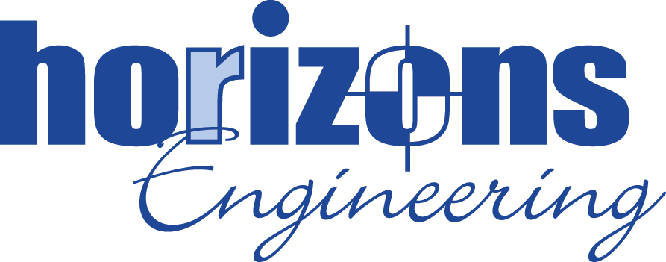
MID-LEVEL STRUCTURAL ENGINEER
Horizons Engineering Inc., a reputable midsize Civil, Environmental, and Structural Engineering and Land Surveying firm, proudly serves New Hampshire, Maine, and Vermont with expertise and dedication. With eight office locations strategically located across the region, we are deeply rooted in our communities and committed to delivering innovative solutions to our clients.

Horizons has an immediate opening for an experienced engineer (4-8 years) to support our growing structural department in our Newmarket – NH office. This position will assist project managers and other members of our team with structural engineering design for residential, commercial, municipal, and institutional projects.

Our staff at Horizons is a close‐knit group of hard‐working individuals who value client service, and design innovation. A successful candidate will have a strong work ethic, desire to learn, and interest in working on a wide range of structural engineering projects throughout New England.
Essential Job Duties:
- Structural Engineering design of municipal, commercial, residential, and institutional projects.
- Drafting and detailing in CAD.
- Prepare reports and documents related to structural engineering projects.
- Design various structural engineering-related projects including single-family homes, multi-family residences, commercial buildings, foundation systems, and retaining walls.
- Construction Services Assistance.
- Same-day travel (less than 10%).

Required Skills and Qualifications:
- Bachelor of Science in civil engineering or related field.
- 4-8 years of professional experience in the practice of structural engineering in New England or a similar setting.
- Experience with AutoCAD design software.
- Experience with wood, structural steel, and reinforced concrete design.
- Sound understanding of structural engineering fundamentals.
- Strong technical skills.
- Ability to complete fieldwork.
- Strong communication and interpersonal skills.
- Valid driver’s license.
- Experience with structural design software.
- Experience managing projects, writing proposals, and doing billing is preferred but not required.

Benefits:

At Horizons Engineering Inc., we prioritize the well-being and professional growth of our team members.

- Competitive Salary and Insurance Benefits: We offer a competitive salary along with comprehensive insurance benefits that cover health, dental, and life insurance. This ensures our employees, and their families, have the necessary support and peace of mind.
- Paid Time Off: Employees enjoy paid holidays and personal time off, allowing for a healthy work-life balance and the opportunity to recharge and spend time with loved ones.
- 401k Plan: Our company 401k plan helps employees save for their future and plan for a comfortable retirement.
- Continuing Education Support: We believe in the importance of lifelong learning and professional growth. Horizons Engineering provides support for continuing education, including reimbursement for professional development courses, certifications, and seminars.
- Supportive Work Environment: Our workplace culture is supportive and inclusive, with ample opportunities for career advancement. We pride ourselves on fostering a work-life balance and providing flexibility to meet the diverse needs of our team.
- Dog-Friendly Office: Understanding that pets are part of the family, our office is dog-friendly, allowing employees to bring their furry friends to work.
- Lunch 'n Learns: We regularly host Lunch 'n Learns where employees can enjoy a meal while engaging in informative sessions on various topics related to their professional and personal development.
- Annual Company Party: To celebrate our collective achievements and build camaraderie, we host an annual company party, providing a fun and relaxed environment for employees to connect and unwind.

At Horizons Engineering, we are dedicated to creating an environment where our employees can thrive both professionally and personally. Our comprehensive benefits package is a testament to our commitment to our team's overall well-being and success.

Interested candidates should forward a cover letter and resume to:

Human Resources Manager
Horizons Engineering Inc.
34 School Street
Littleton, NH 03561
Or via email to hrmgr@horizonsengineering.com

For more information, check us out on Facebook or at www.horizonsengineering.com

Horizons Engineering Inc. Is an equal opportunity employer

